NAME | REGISTRANION NO. | ROLES
IAN BWALEI | E020-01-1527/2023 | REQUIREMENTS ANALYST
TITUS KAIBOS | E020-01-0927/2023 | REQUIREMENTS ANALYST
GILBERT KEMBOI | E020-01-0926/2023 | SYSTEM DESIGNER
BRIAN SOME | E020-01-0929/2023 | SYSTEM DESIGNER
ARNOLD MURITHI | E020-01-0937/2023 | JIRA PROJECT MANAGER
ALVIN NG’ANG’A | E020-01-2078/2023 | JIRA PROJECT MANAGER
GLORIA CHEPCHUMBA | E020-01-0912/2023 | UML DIAGRAMS
ABIGAEL CHEROTICH | E020-01-0913/2023 | UML DIAGRAMS
PAULINE WAMBETE | E020-01-0881/2023 | DOCUMENTATION LEAD
KIRUI CHEPKURUI | E020-01-0905/2023 | DOCUMENTATION LEAD

BACHELOR OF SCIENCE IN TELECOMMUNICATION AND INFORMATION ENGINEERING
PROJECT NAME: STUDENT REGISTRATION SYSTEM
DATE: 22ND JANUARY 2026
JIRA REPORT

INTRODUCTION
This document presents the Agile project management activities undertaken for the development of the Student Registration System using Jira. The purpose of this report is to demonstrate how agile principles and tools were applied to plan, organize, track, and manage project tasks during the early stages of the Software Development Life Cycle (SDLC).
Jira was used as the primary project management tool to support collaborative planning, backlog management, sprint execution, and workflow tracking. The project was structured using the Scrum framework, which enabled the team to divide the system into manageable units of work known as epics and user stories. These work items were then prioritized and scheduled into a two-week sprint to ensure systematic progress toward the project objectives.
The report documents the setup of the Jira project, including the creation of epics, user stories, and sprint planning activities. It also provides visual evidence through screenshots to illustrate backlog organization, active sprint management, task workflows, and team assignments. Each section of the report explains how Jira was used to align tasks with project goals, ensure accountability among team members, and track progress effectively.
Overall, this Jira report demonstrates the team’s understanding and practical application of agile project management concepts, highlighting how Jira facilitates transparency, coordination, and efficient task management in the development of the Student Registration System.
Section 1:Jira set up
Backlog with Epics
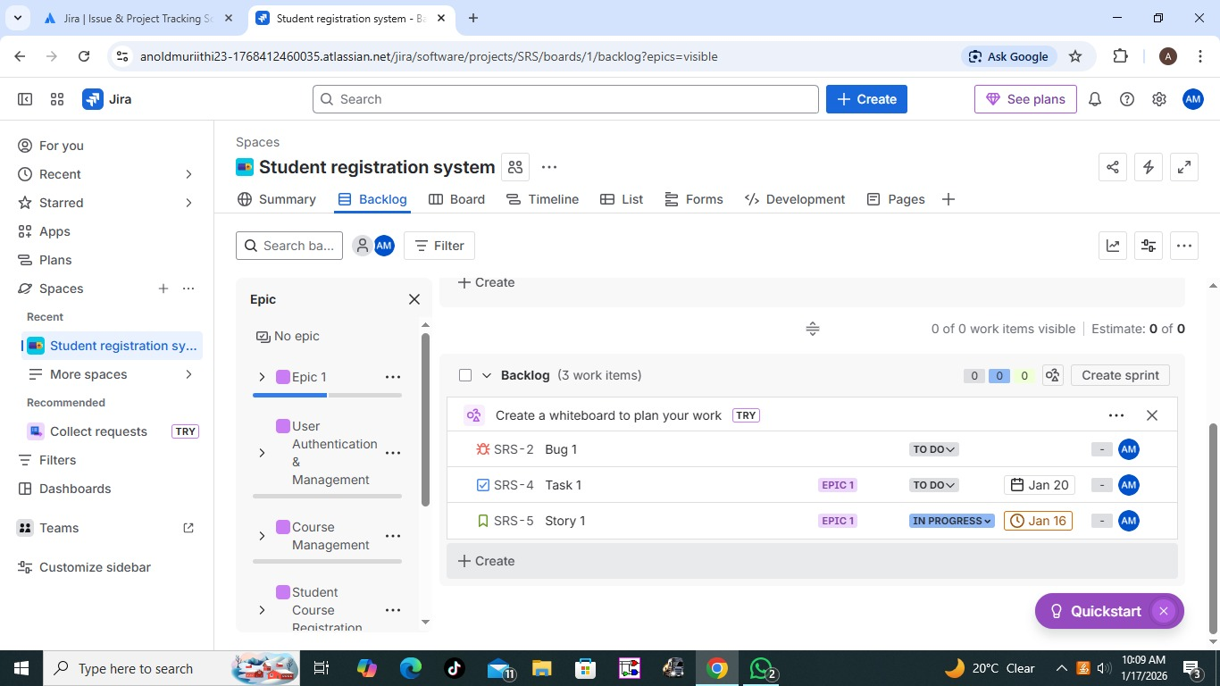
It represents a big goal or initiative that spans multiple sprints, helping teams organize, track, and deliver complex outcomes. These 4 Epics were chosen because they represent the critical functional pillars of the system. "User Authentication" ensures security, "Course Management" handles data entry, "Enrollment" is the core business process, and "Reporting" serves the stakeholders' need for information.

Section 2: User Stories and Sprint Planning
Active Sprint with user stories and story points
Create sprint
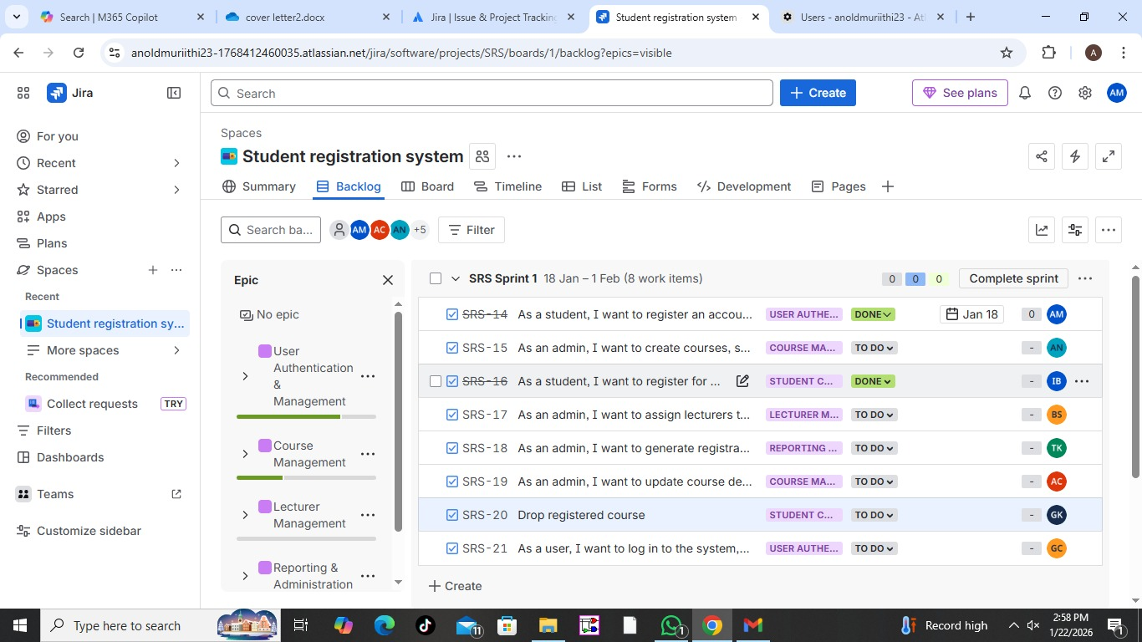
This stage represents the initial state of our 2-week sprint. These tasks are "created" and ready for work but have not yet been started. For our Student Registration System, this includes stories like "Registering an account" or "Viewing the Course Catalog".
Purpose:
It serves as a prioritized list of work that the team has committed to finishing by the deadline.
In progress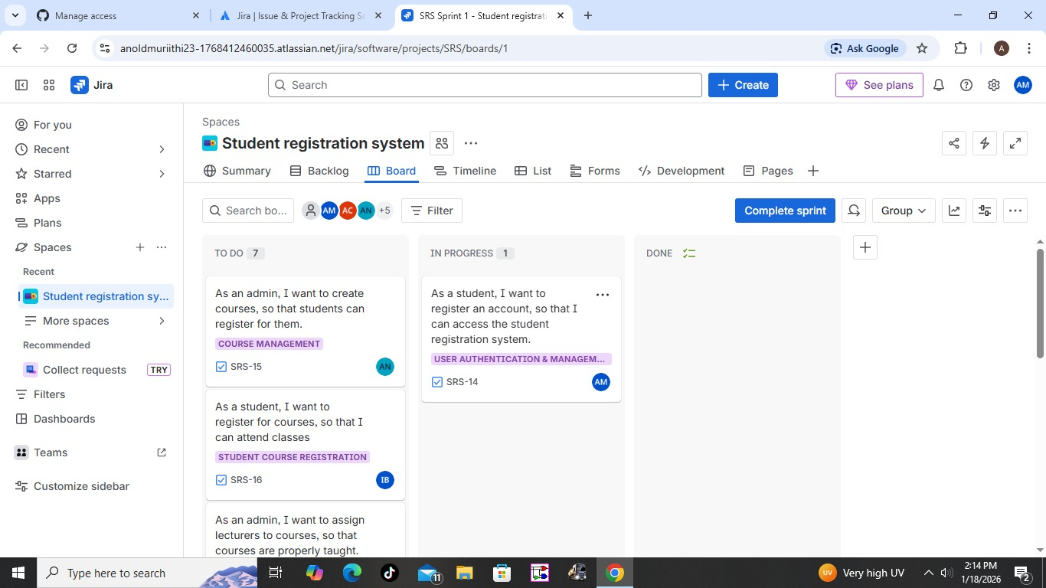

When a team member begins an activity—such as drafting the SRS or creating UML diagrams—they move the corresponding Jira issue to this column.
Purpose:
This prevents "work-in-progress" bloat and ensures no two members are working on the same task simultaneously. For example, if the Design Lead is working on the Class Diagram, the ticket is moved here so the rest of the team knows it is being handled

Done sprint
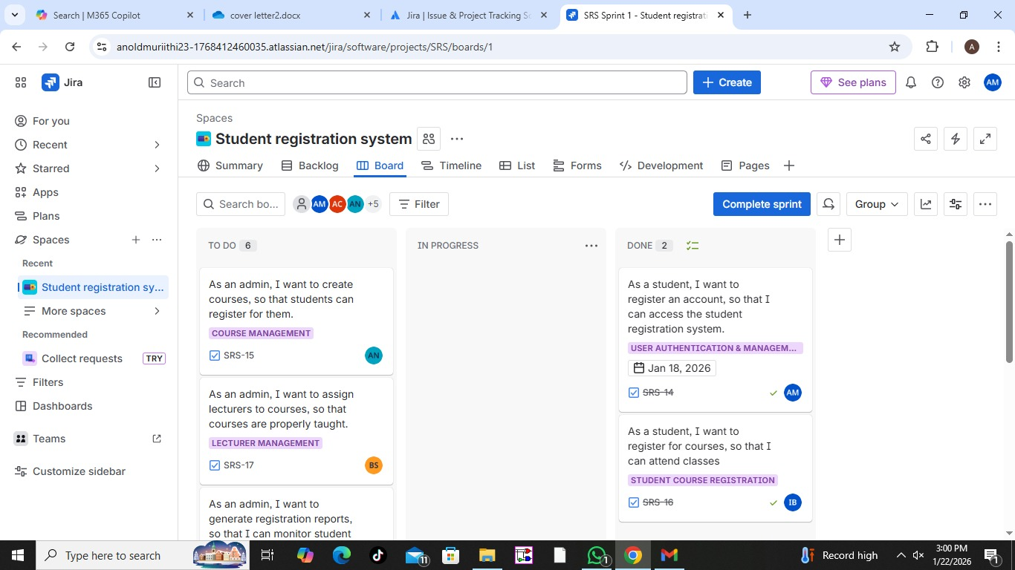A task is moved to "Done" only when it meets our "Definition of Done". For this project, that means the documentation is complete, screenshots are captured, and the file has been committed to the documentation branch on GitHub.
Purpose:
This provides the team with a sense of progress and allows the Jira Manager to track how many story points have been completed versus what remains.

Board view
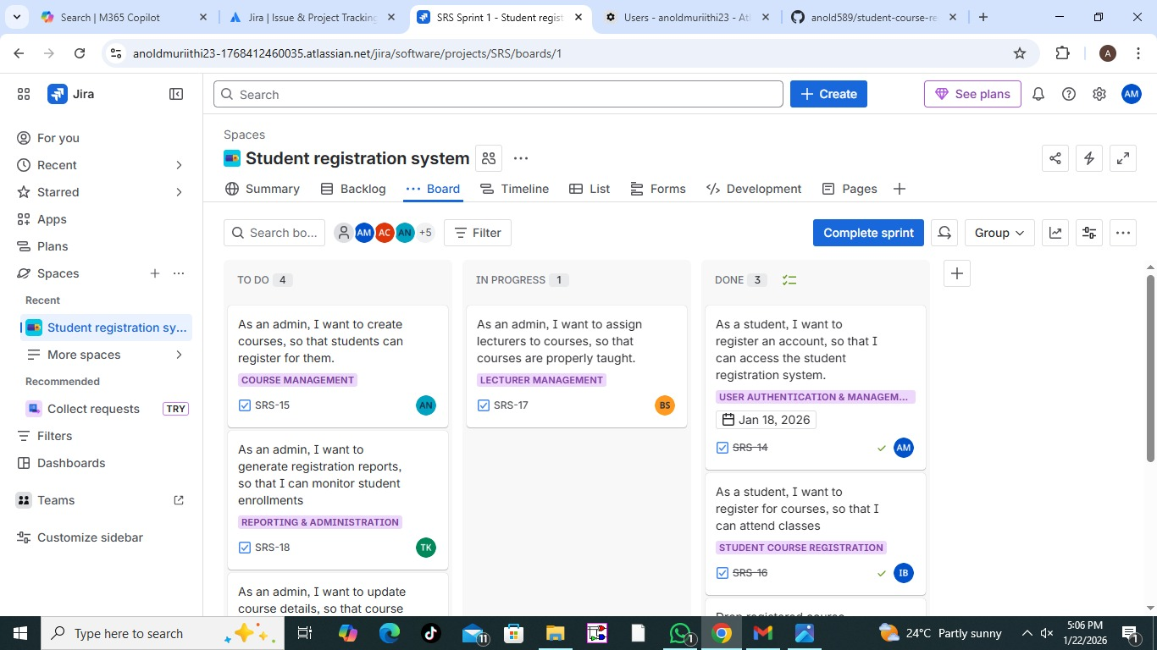
Our workflow allows the team to track progress visually. Moving a task to "In Progress" prevents two members from working on the same requirement, while "Done" signifies the requirement has been documented and verified

Section 3: Detailed Work Items
Detailed user story
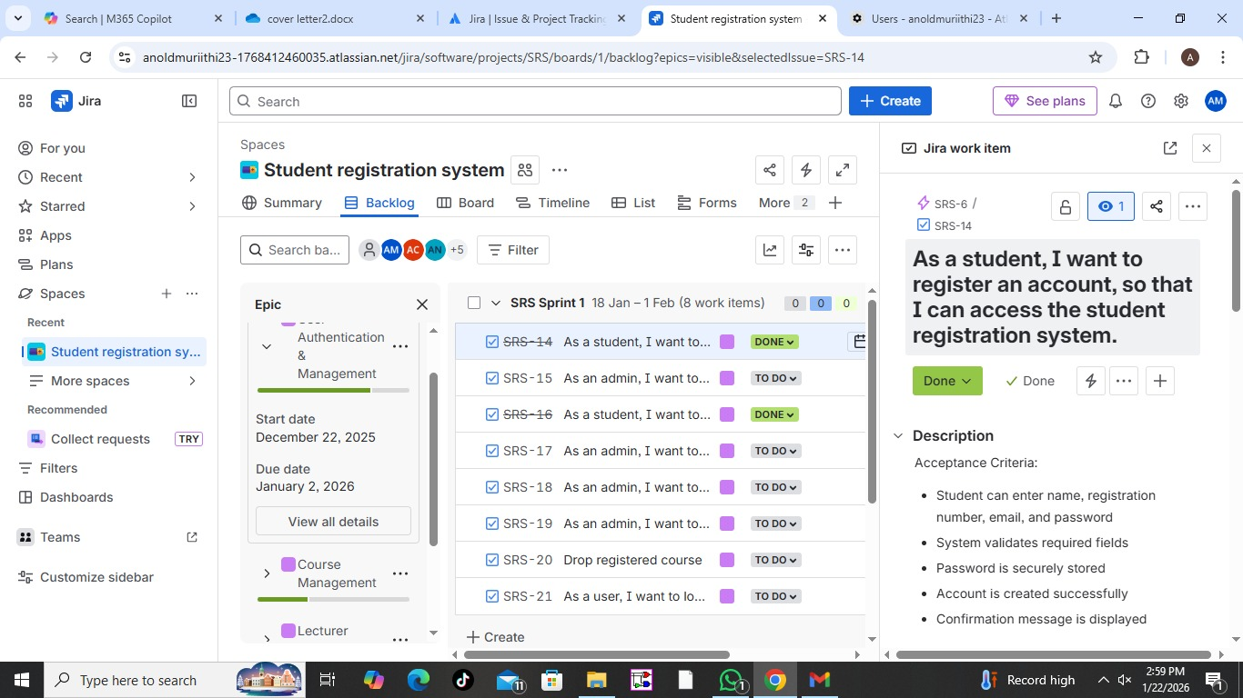
This story follows the format: "As a student, I want to register for units online so that I can enroll without visiting the campus". Success is measured by the Acceptance Criteria: the system checking prerequisites, confirming capacity, and updating the database
Section 4: Team Assignment and Workflow
Team assignment
Team Roles
- Requirements Analyst Ian Bwalei,Titus Kaibos
- System Designer Brian Some, Gilbert Kemboi
- Jira Project Manager Anold Muriithi,Alvin Ng'ang'a
- Documentation Lead Ivy Chepkurui, Pauline Wambete
- UML diagrams Abigael Cherotich,Gloria Chepchumba
To ensure high accountability and specialized focus, we distributed tasks based on the specific roles:
- Requirements Lead: Responsible for drafting the Functional and Non-Functional Requirements in the Backlog.
- Design Lead: Focuses on converting requirements into technical tasks that align with our UML diagrams.
- Jira Manager: Oversees the Scrum board, assigns story points using the Fibonacci scale, and manages the sprint timeline.
- Documentation Lead: Ensures all screenshots, SRS details, and reports are correctly formatted and committed to the GitHub documentation branch.
This distribution ensures that every member contributes to at least 2 major commits and that no single member is overwhelmed by the project scope.
Workflow transitions


Our team utilizes a standard Scrum Workflow to track the progression of user stories from inception to completion:
- To Do: All user stories selected for the 2-week sprint start here. It represents our committed workload.
- In Progress: When a member begins working on a task (e.g., "Designing the Class Diagram"), they transition the ticket to this column. This provides real-time transparency and prevents team members from duplicating work on the same requirement.
- Done: An issue is only moved to "Done" once the deliverable is committed to GitHub and meets the defined Acceptance Criteria.
CONCLUSION
This Jira report demonstrates the practical application of agile project management principles in the development of the Student Registration System. By using Jira, the team was able to effectively plan tasks, assign responsibilities, track progress, and maintain transparency throughout the sprint. The structured use of epics, user stories, and workflows ensured that project goals were met in an organized and collaborative manner.

